**ELECTROMAGNETIC RADIATION**

**Model 1: Characteristics of Waves.**

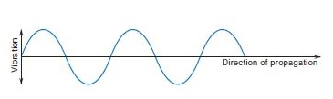

The figure above represents part of a wave. Label wavelength, crest, trough and amplitude. Why frequency can’t be labelled on the wave.

1) Based on the figure above, define wavelength.

2) Suppose that the wave depicted above is travelling to the left at a speed of 35 cm/sec and that λ = 2.5 cm. (a) How long would it take for 1 wavelength (or 1 cycle of the wave to travel through the origin of the graph?

3) Is the following statement true or false: For waves travelling at the same speed, the longer the wavelength the greater the frequency? Why

4) A sunbather forgot their sunblock on the beach, and got an unhealthy dose of UV radiation of 5.66 x 1016 Hz

a) What is the wavelength of these particular UV waves?

b) What is the energy of these waves in J?

**Model 2: Photons and Radiation Energy**





Complete the following table;

